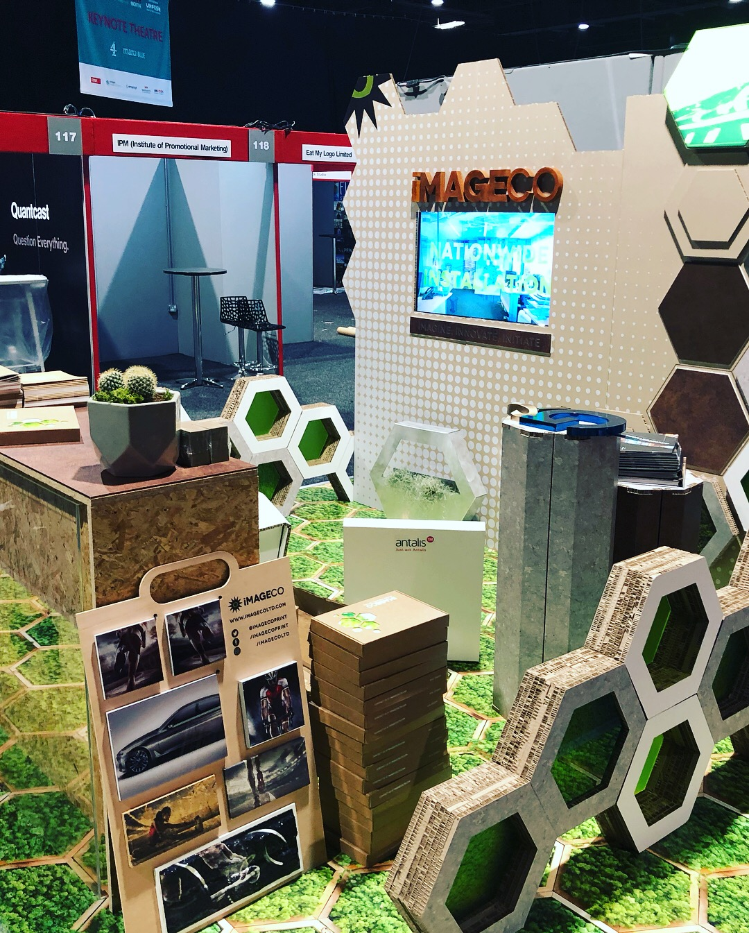
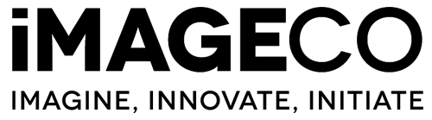
t

Next generation

competition

3D Design

Brief overview

We are looking for the next whizz in 3D design and cardboard engineering. We want you to develop a brand-new cardboard POS design. We want to see stand-out displays that we have never seen before.

They should represent imagination and technical expertise. We’re looking for an understanding of 3-dimensional design, structure, simplicity and sustainability.

Successful entrants will demonstrate a strong understanding of technical drawing for assembly, 3D software and the ability to transform ideas into models.

The Product

We want you to think about a product line of your own making. This could be for retail or an event. Big brands such as Adidas are now looking for their window and store campaigns to be completely sustainable.
Large events often result in unwanted waste. By using paper-based products we can reduce the amount of waste going to landfill and recycle event stands and props.

Tell us about the products and how you think they should be displayed in a retail environment and why. Think about how your products would stand out in a supermarket or how they would look in your own branded store. We really want to see lots of thinking behind this!

The execution

Now bring your ideas to life with 3D modelling of your own retail structure. This could be an experiential environment in a store or simply an innovative way to display your products.

We want to see technical brilliance in your 3D designs.

Thinking points

Going Green
At Imageco we’re really big into the environment, if you can think of working a green angle into your branding or even some ideas on the materials being used in the execution, we’d be impressed to see what you come up with. We will be looking at research methods.

Inspire Us
We want to see something really unique here, maybe something we’ve never seen before. Think about how you can cram as much creativity into your entry as possible. Don’t be afraid to be wild with your ideas, we’ll be looking for those innovative thinkers. Brainstorming and mood boards are a good technique to start with. Tip: Look on Pinterest.

Sell us the Story
The more backstory you put into your entry the better. Really take the time to explain why you’ve made certain decisions. We want to see sketches, even doodles as part of the thought process, we will be looking for how an idea was born and developed. Development sketches are as important if not more so than the final presentation.

Entry Instructions

You can supply any type of file format for your project, just make sure you follow the brief and make relevant annotations on designs.

Fill in the form below along with all other documents you’ve produced, stick it in a zip file and send to nextgen@imagecoltd.com Ensure file sizes are below 15mb in size. Ideally as PDF.

Full Name

Date Of Birth

Address

Phone Number

Project name

