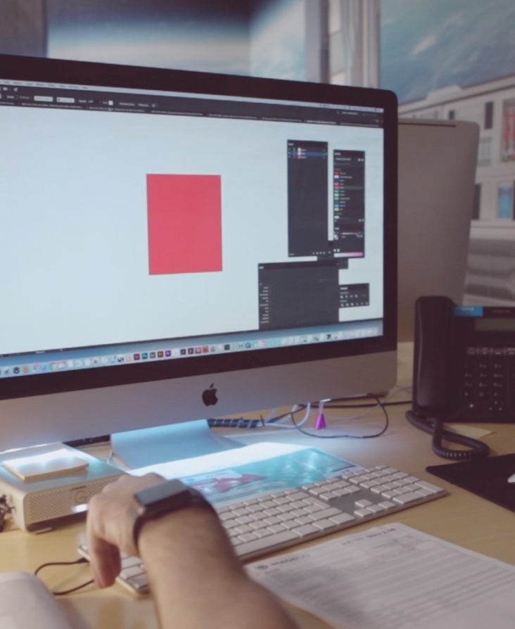
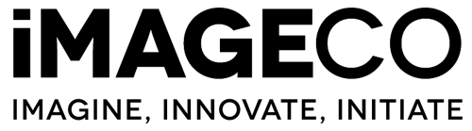

Next generation

competition

Design Category

Brief overview

We are looking for you to create a launch campaign for a brand of your making.

The company could be lifestyle, clothing, food or drink or even the latest gadget – use your imagination!

We’d like to see how you tackle logos, colours, fonts and branding. We’d then like you to apply your brand vision to various types of physical signage.

These include: - Instore POS and Graphics, Store Front Signage, Exhibitions and Events, Information Signage, Posters, Billboards. You must apply your brand to at least three mediums. We want to see inspiration and something truly unique.

The Brand

We want to know all about your brand what it stands for, its values and its target audience.
We then want you to look at some creative outputs, start with logo designs, straplines and colours. Explain to us why you’ve chosen certain fonts and shapes, how is this relevant to your brand and what you’re selling.

The execution

Now we want to see your brand really come to life. Think about your brand launch and how your designs would look across printed materials. We’d like to see a mix of:
- Instore POS – all of the posters, store campaigns, product holders or anything else you can think of that would make your product stand out in a retail environment
- Storefront signage – will your brand have its own stores? How will the shop fronts look? We need to see some really well mocked up examples that show us exactly how your store would look
- Ad campaigns – How would your brand look in print? We’re talking billboards, poster ads, bus shelter ads and even train station take overs
- What have we missed? – If you think your brand would be somewhere else, maybe the main sponsor of a football team or a stadium, maybe on the side of a plane – you decide, just make sure its original and awesome!

Thinking points

Going Green
At Imageco we’re really big into the environment, if you can think of working a green angle into your branding or even some ideas on the materials being used in the execution, we’d be impressed to see what you come up with.

Inspire Us
We want to see something really unique here, maybe something we’ve never seen before. Think about how you can cram as much creativity into your entry as possible.

Sell us the Story
The more backstory you put into your entry the better. Really take the time to explain to use why you’ve made certain decisions.

Entry Instructions

You can supply any type of file format for your project, just make sure you follow the brief and make relevant annotations on designs.

Fill in the form below along with all other documents you’ve produced, stick it in a zip file and send to nextgen@imagecoltd.com

Full Name

Date Of Birth

Address

Phone Number

Project name

